PARTS LIST:
1 | Grille Guard | 2 | 12mm Plastic Retainers
1 | Driver/Left Frame Mounting Bracket | 8 | 12-1.75mm x 35mm Hex Bolts
1 | Passenger/Right Frame Mounting Bracket | 16 | 12mm x 32mm OD x 3mm Flat Washers
1 | Driver/Left Lower Mounting Bracket | 8 | 12mm Lock Washers
1 | Passenger/Right Lower Mounting Bracket | 8 | 12mm Hex Nuts
 |  | 1 | 4mm Allen Wrench
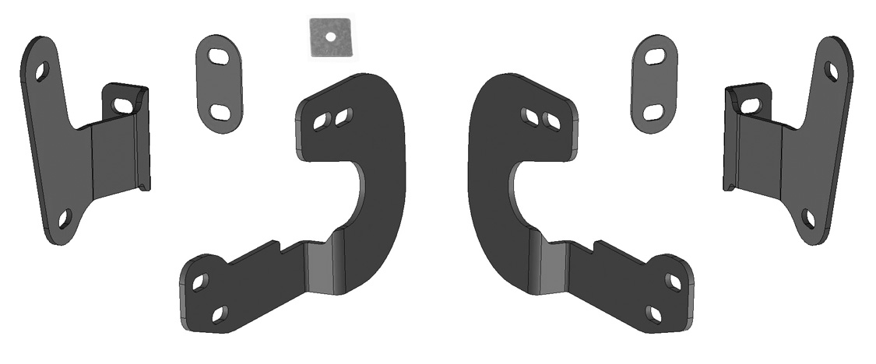
Passenger/Right Frame Bracket
Driver/Left Frame Bracket
(2) Plastic Retainers


Passenger/Right Lower Mounting Bracket

Driver/Left Lower Mounting Bracket

PROCEDURE:
REMOVE CONTENTS FROM BOX. VERIFY ALL PARTS ARE PRESENT. READ INSTRUCTIONS CAREFULLY BEFORE STARTING INSTALLATION. ASSISTANCE IS RECOMMENDED TO AVOID POSSIBLE INJURY OR DAMAGE TO THE VEHICLE. MINOR PLASTIC TRIMMING IS REQUIRED.
FRONT PARKING SENSORS WILL BE BLOCKED AND MUST BE TURNED OFF (IF EQUIPPED).
- Starting at the front-driver side of the front bumper, remove the plastic cover, (if equipped), covering the bumper bolts on both sides of the tow hook, (Figures 1 & 2). Cover re-installation recommended on models with driver/left side adaptive cruise control sensor attached to bumper.
- Remove the (2) outer bumper bolts, (Figure 2). IMPORTANT: Do not remove the inner bumper bolts or the bumper may fall. Only remove the outer bumper bolts.
- Select the driver/left side Frame Bracket. NOTE: Models with plastic covers removed in Step 1, cut openings in outer pocket on covers to clear Brackets, (Figure 1 & 3). Slide covers over Brackets but leave covers loose until after final adjustment, (see Step 12).
Reuse the factory bolts to attach the Bracket and plastic cover to the bumper, (Figure 4).
- Make sure there is clearance between the top and bottom of the Frame Bracket and the opening in the bumper. Do not tighten hardware at this time.
- Repeat Steps 1—4 for passenger/right side Frame Bracket installation.
- Next, remove the plastic air dam from the bottom of the bumper and place it on a clean, stable work surface, (Figure 5). Note the location and type of all factory hardware for reinstallation.
- From under the driver/left side of the bumper, locate the (2) outer hex nuts attaching the car catcher frame extension to the outside of the frame, (Figure 6). Remove (1) of the (2) factory hex nuts, (Figures 7 & 8). Thread (1) Plastic Retainer onto the threaded end of the double bolt plate. Remove the second factory nut from the bolt plate. NOTE: The Plastic Retainer is designed to help hold the factory double bolt plate in place in the frame and to help with bracket installation. Do not allow the double bolt plate to fall into the frame channel.
- Select the driver side Lower Mounting Bracket. Reuse the (2) factory hex nuts to attach the Bracket to the double bolt plate, (Figure 8 & 9). Do not tighten hardware at this time.
- Repeat Steps 7 & 8 for passenger/right side Lower Mounting Bracket installation.
- With assistance, position the Grille Guard up to the outside of the Mounting Brackets.
- Attach the Grille Guard to the Frame Brackets and Lower Mounting Brackets with the included (8) 12mm x 35mm Hex Bolts, (16) 12mm Flat Washers, and (8) 12mm Hex Nuts, (Figure 10). Do not tighten hardware at this time. NOTE: 12mm Lock Washers not needed for this step.
- Level and adjust the Grille Guard and fully tighten the Bracket-to-vehicle hardware only at this time. Temporarily remove the Grille Guard. Snap modified plastic covers in place, (also see Step 3).
- Hold the plastic air dam up in position against the Lower Brackets and mark the location of the Brackets onto the top of the air dam, (Figure 11). Measure the location of the Lower Brackets and transfer these measurements onto the back of the air dam, (Figure 12). Place the air dam back up to the (2) Lower Mounting Brackets to verify location before cutting. Check all measurements on the vehicle. Once absolutely satisfied, use a hacksaw blade or utility knife to carefully cut (2) openings in air dam. Check fit, trim as necessary and reuse the factory hardware to reinstall air dam over Lower Brackets. IMPORTANT: Do not cut through the top or bottom edge of the air dam, (Figure 12). NOTE: It may be necessary to loosen or temporarily remove the Lower Mounting Brackets only to reinstall the air dam.
- Reinstall the Lower Brackets through the air dam “if previously removed”.
- Reinstall the Grille Guard as described in Steps 10—12. Level and adjust Grille Guard and fully tighten all hardware.
- On models with grille emblem mounted camera, use included 4mm Allen Wrench to remove center window screen from back of Grille Guard, (Figure 13).
- Do periodic inspections to the installation to make sure that all hardware is secure and tight.

To protect your investment, wax this product after installing. Regular waxing is recommended to add a protective layer over the finish. Do not use any type of polish or wax that may contain abrasives that could damage the finish. Mild soap may be used to clean the Guard.

Driver/left Side Installation Pictured

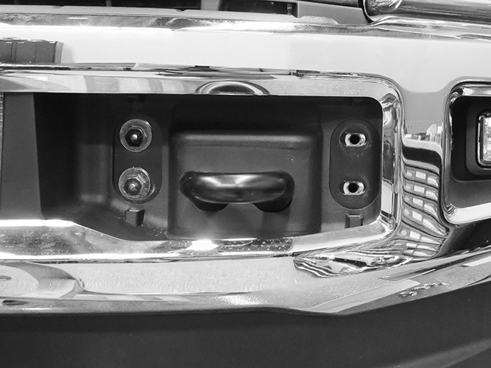
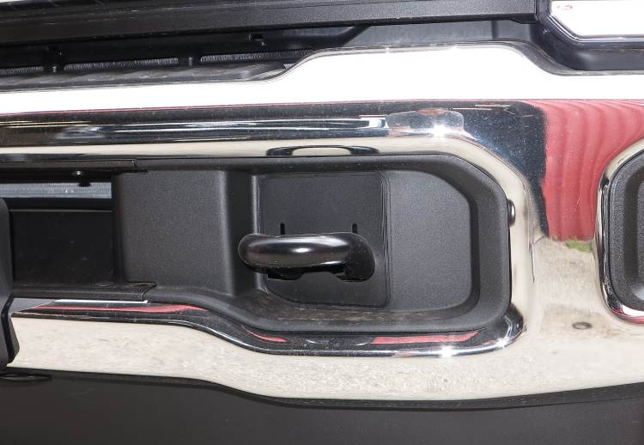

(Fig 2) Remove outer bumper bolts only
(Fig 1) Remove cover over bumper bolts.

Driver/left Side Installation Pictured

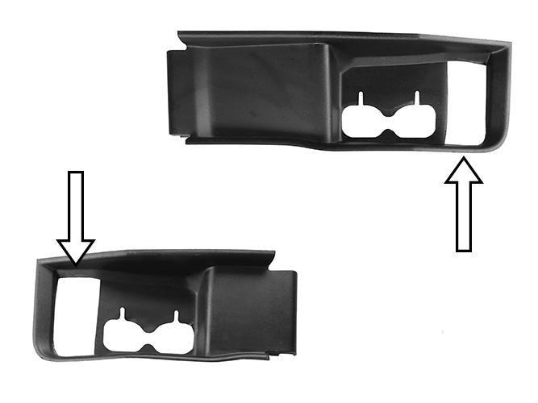

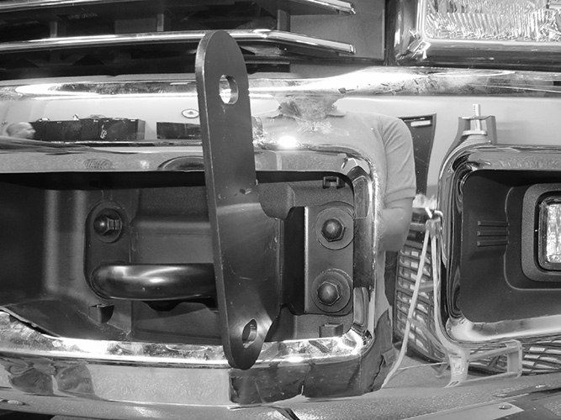

(Fig 3) Cut plastic covers to clear base on Brackets for reinstallation “if desired”

(Fig 4) Reuse factory bumper bolts to attach driver/left Frame Bracket to bumper

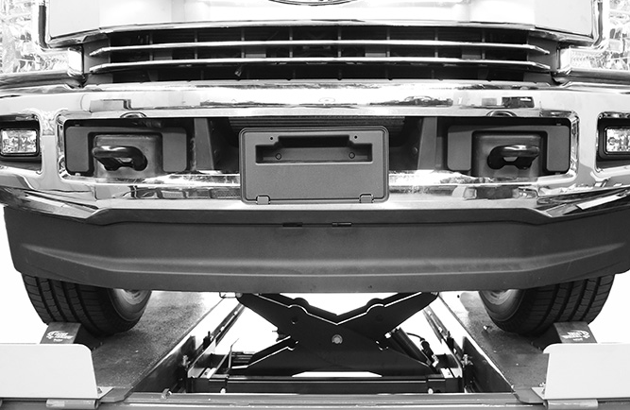
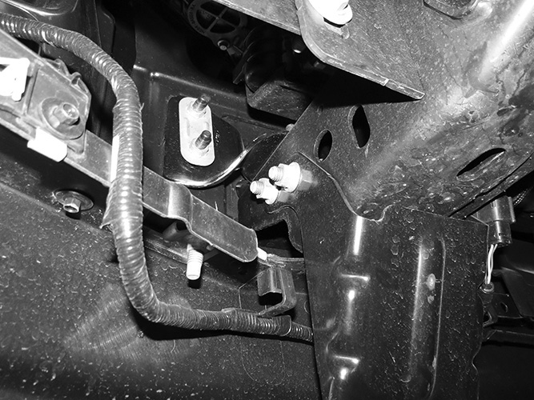

(Fig 5) Remove plastic air dam from bottom of bumper.

(Fig 6) Driver/left frame extension pictured
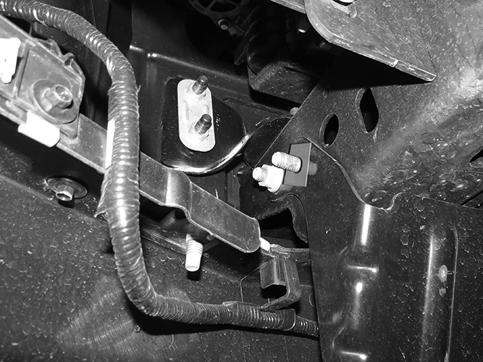

Remove (1) nut, thread (1) 12mm Plastic Retainer onto threaded end before removing remaining hex nut

(Fig 7) Driver/left frame extension pictured

Driver/left Side Installation Pictured

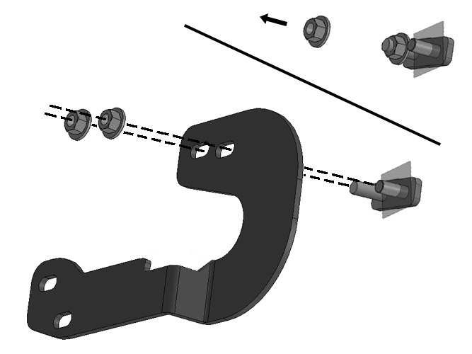

Remove (1) nut, thread (1) 12mm Plastic Retainer onto threaded end before removing remaining hex nut

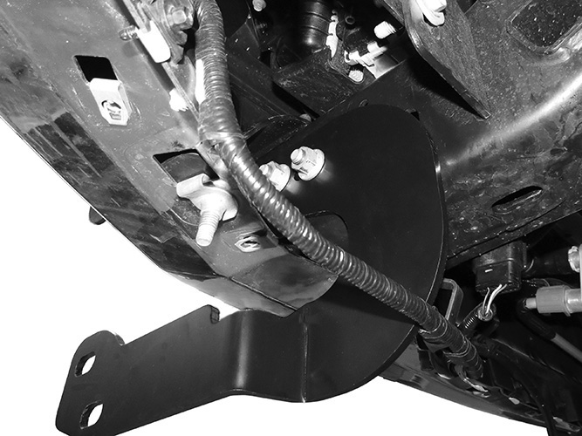
Front

(Fig 8) Driver/left Lower Bracket illustrated. Reuse factory hardware to attach Bracket to side of frame and frame extension

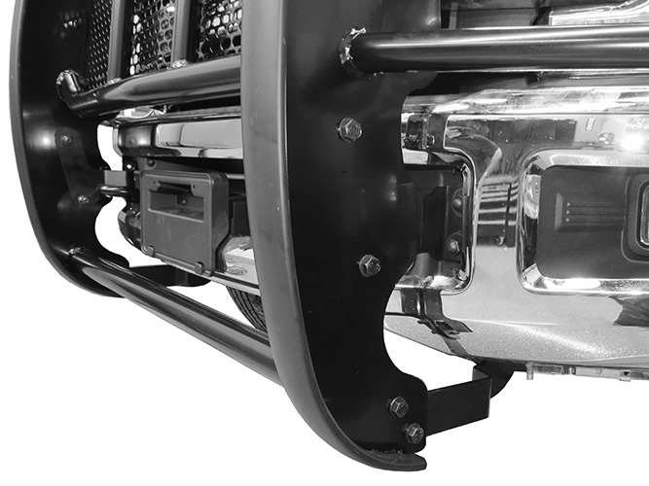
Front

Front

(Fig 9) Driver/left Lower Bracket pictured. Reuse factory hardware to attach Bracket to side of frame and frame extension

(4) 12mm x 35mm Hex Bolts
(8) 12mm Flat Washers
(4) 12mm Lock Washers
(4) 12mm Hex Nuts

(Fig 10) Attach Grille Guard to outside of Brackets (arrows)

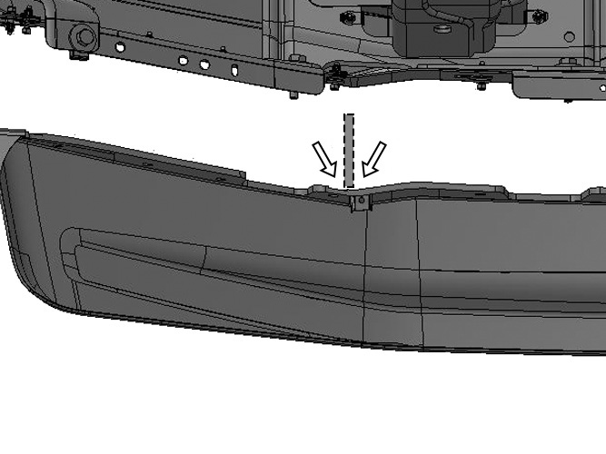
Hold air dam up against bottom of Brackets (dashed line for reference).
Mark location of Bracket onto top of air dam (arrows)

(Fig 11) Driver side-back of air dam illustrated

Driver/left Side Installation Pictured

Do not cut through the top or bottom edges of the air dam. Only remove enough material to clear the Brackets

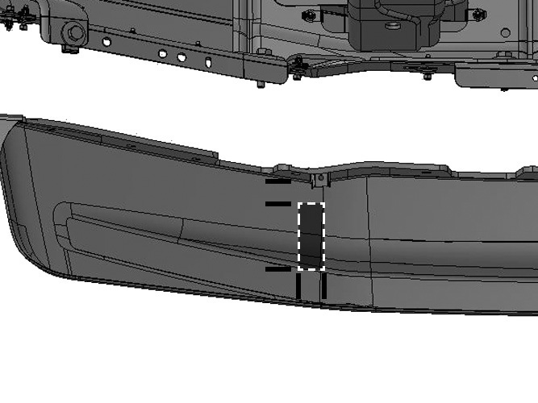

1-1/4” down

2-1/2”
(Fig 12) Driver side-back of STD air dam illustrated. All measurements are for reference and example only, check all measurements before cutting air dam.

3/4” wide slot
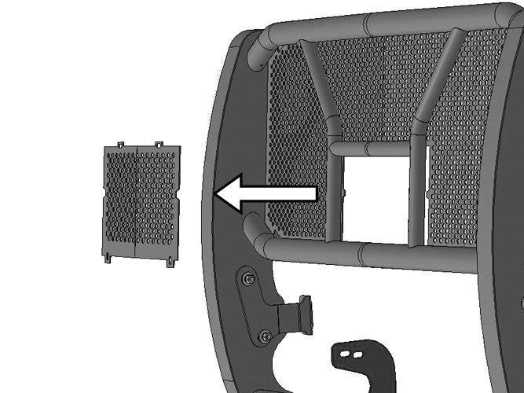

Complete Installation
(Fig 13) On models with grille mounted camera, remove center window screen

