PARTS LIST:

1 | HD Replacement Front Bumper | 32 | 12mm x 32mm x 3mm Flat Washers
1 | Driver/left side Frame Bracket | 4 | 12mm x 24mm x 2.5mm Flat Washers
1 | Passenger/right side Frame Bracket | 22 | 12mm Lock Washers
1 | Driver/left side Support Bracket | 22 | 12mm Hex Nuts
1 | Passenger/right side Support Bracket | 8 | 6mm x 20mm Hex Bolts
1 | Driver/left side Fill Panel (ONLY for 05-07 models) | 16 | 6mm x 12mm x 1.6mm Flat Washers
1 | Passenger/right side Fill Panel (ONLY for 05-07 models) | 8 | 6mm Nylon Lock Nuts
2 | License Plate Plugs | 4 | 5mm x 20mm Button Head Bolts
2 | 12mm Plastic Retainers | 8 | 5mm x 10mm x 1mm Flat Washers
2 | 12mm x 50mm Double Bolt Plates | 4 | 5mm Nylon Lock Nuts
4 | 12mm x 50mm Single Bolt Plates | 1 | Allen Wrench (5mm)
14 | 12mm x 50mm Hex Bolts

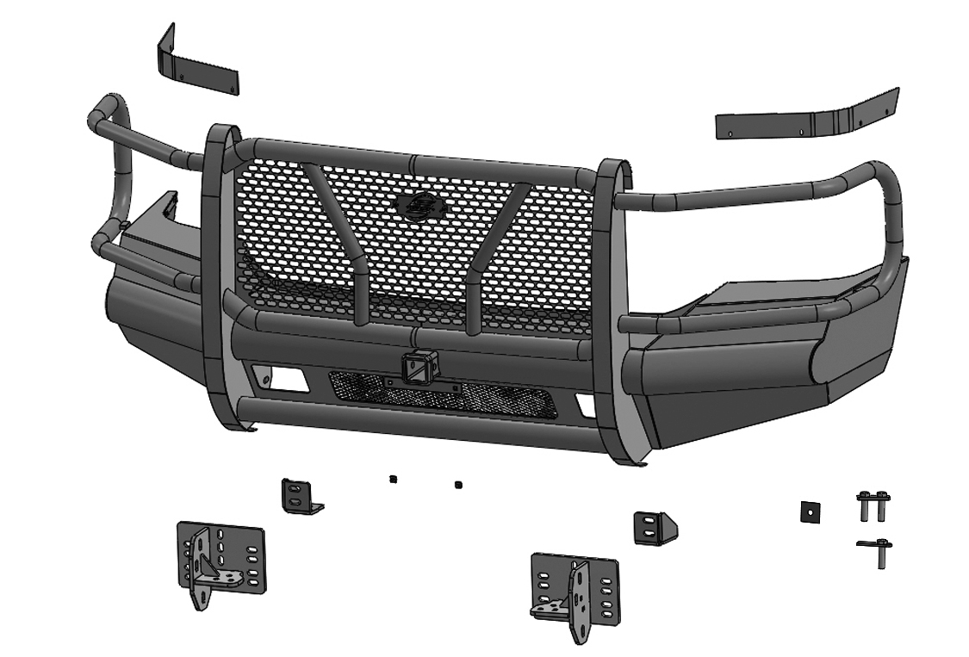
Passenger/right side Fill Panel
Driver/left side Fill Panel
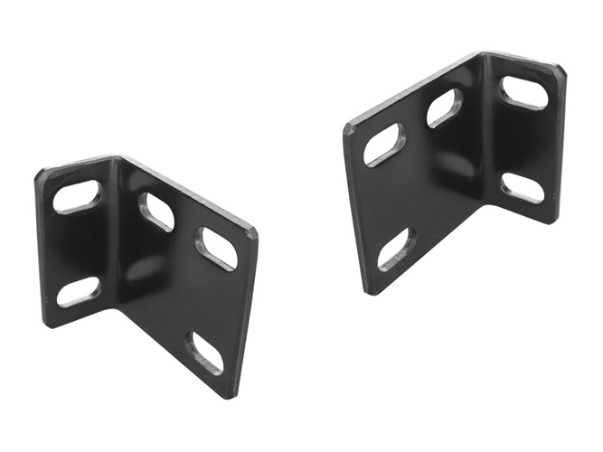

(2) 12mm Double Bolt Plates
Passenger/right side Support Bracket
Driver/left side Support Bracket
(2) Plastic Retainers

Plastic Plugs

Passenger/right side Frame Bracket
(4) 12mm Single Bolt Plates
Driver/left side Frame Bracket

PROCEDURE:
REMOVE CONTENTS FROM BOX. VERIFY ALL PARTS ARE PRESENT. READ INSTRUCTIONS CAREFULLY BEFORE STARTING INSTALLATION. ASSISTANCE IS HIGHLY RECOMMENDED TO AVOID POSSIBLE INJURY OR DAMAGE TO THE VEHICLE.
- Remove the license plate. On models with factory fog lights, unplug both lights. Release wiring harness from the clips attached to the back of the bumper, (Figure 1). Move harness away from bumper.
- Next, remove the (3) factory bolts, per side, to remove the lower cross member if equipped, (Figures 2A & 2B). Remove the factory bolts on the outer bumper supports attaching the outer ends of the bumper to the sides of the frame, (Figure 3).
- Place blocks or jack stands under the front bumper to support it during mounting bolt removal. Once the bumper has been safely supported, remove the (4) factory bumper bolts, (Figures 4 & 5). WARNING! Assistance is required to hold the bumper in place during bolt removal to prevent the bumper from falling. Carefully slide the bumper off over the tow hooks.
- Remove the driver/left side tow hook, (Figure 6). Select the Driver/left side Support Bracket, (Figure 7). Insert (2) 12mm Single Bolt Plates into the bottom slots on the Bracket. Next, insert (1) 12mm Double Bolt Plate in through the remaining slots in the Bracket. Thread (1) 12mm Plastic Retainer onto the Bolt Plate tight against the Bracket, (Figure 8). NOTE: The Plastic Retainer is used to help prevent the Double Bolt Plate from falling and to aid in Frame Bracket installation.
- Slide the Support Bracket assembly into the channel on the frame, (Figure 9). Insert the (2) Single Bolt Plates in through (2) factory tow hook holes on the bottom of the frame. Secure the Bracket to the bottom of the frame using (2) 12mm x 32mm Flat Washers, (2) 12mm Lock Washers and (2) 12mm Hex Nuts, (Figure 10). Do not tighten hardware.
- Select the Driver/left side Frame Bracket. On 99-04 models, use the illustration on Figure 11 to help determine the correct mounting slots for Frame Bracket installation. On 05-07 models, use the illustration on Figure 12 to help determine the correct mounting slots for frame Bracket installation.
- Attach the Driver/left side Frame Bracket to the Double Bolt Plate on the Support Bracket with (2) 12mm x 24mm Flat Washers, (2) 12mm Lock Washers and (2) 12mm Hex Nuts, (Figure 13). Secure the Frame Bracket to the front of the frame using (4) 12mm x 50mm Hex Bolts, (8) 12mm x 32mm Flat Washers, (4) 12mm Lock Washers and (4) 12mm Hex Nuts, (Figure 14). Do not tighten hardware.
- Next, reuse the factory tow hook hardware to reinstall the driver/left side tow hook onto the bottom mounting plate of the Frame Bracket, (Figure 15).
- Repeat Steps 4 — 8 for passenger side Support & Frame Bracket installation.
- If equipped, remove the fog light assemblies from the back of the OE Bumper, (Figure 16). Attach the fog light assemblies to the mounts on the back of the HD Bumper using (4) 5mm Button Head Bolts, (8) 5mm Flat Washers and (4) 5mm Nylon Lock Nuts, (Figure 17). Do not tighten hardware at this time.
- On 05-07 models ONLY, select the Driver/left side Fill Panel. Use (4) 6mm Hex Bolts, (8) 6mm Flat Washers and (4) 6mm Nylon Lock Nuts to attach the Fill Panel to the Bumper, (Figure 18). NOTE: The Fill Panel is used to fill in the gap between the top of the Bumper and bottom of the headlight. Repeat this Step for passenger side Fill Panel installation.
- With assistance, carefully position the Bumper Assembly up to the outside of the Frame Brackets. WARNING: To avoid possible injury or damage to the vehicle, do not proceed until the bumper is fully and safely supported.
- Attach the Bumper to the Brackets with the included (6) 12mm x 50mm Hex Bolts, (12) 12mm Flat Washers, (6) 12mm Lock Washers and (6) 12mm Hex Nuts, (Figure 19). Do not tighten hardware.
- Level and adjust Bumper, (if necessary), and tighten all hardware.
- Use the provided (2) Plastic Plugs to attach the license plate to the front of the Bumper, (Figure 20).
- Do periodic inspections to the installation to make sure that all hardware is secure and tight.

To protect your investment, do not use any type of polish or wax that may contain abrasives that could damage the finish. Mild soap may be used to clean the Bumper Assembly.

Driver/left Side Installation Pictured
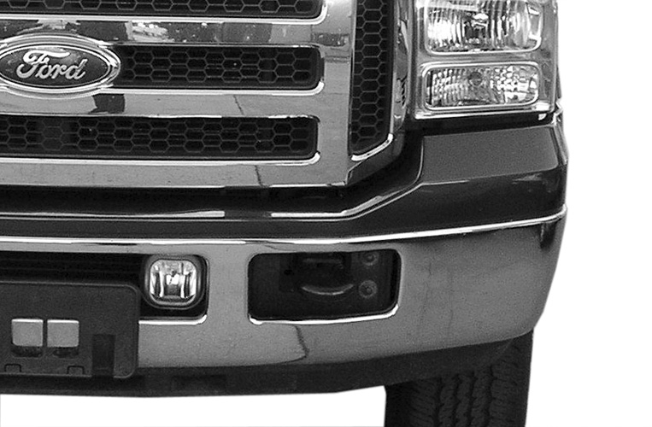
(Fig 1) unplug wire harness from fog light behind bumper
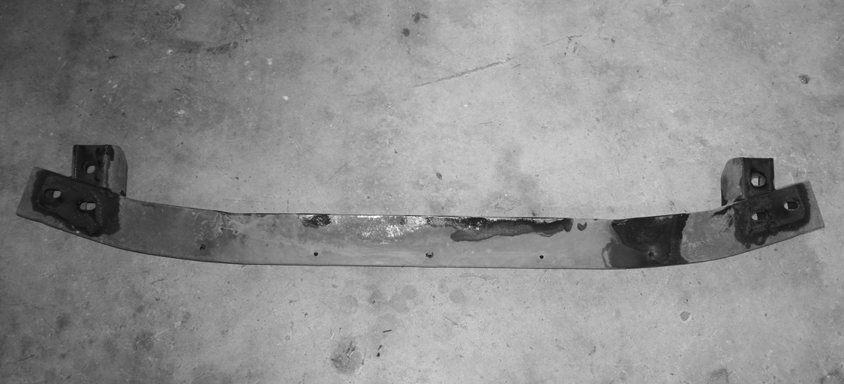
(Fig 2B) Cross member removed

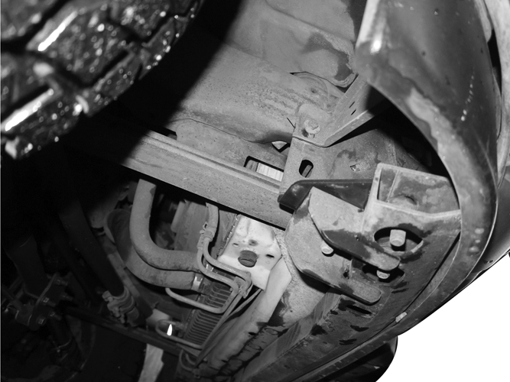
(Fig 2A) Models equipped with lower cross member must remove factory bolts, 3 per side.
Front

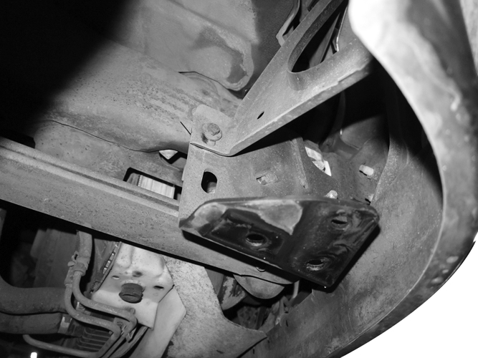
(Fig 3) Remove factory bolt attaching outer bumper bracket to frame, if equipped (passenger side)
Front

WARNING! Do not remove bumper bolts unless the bumper is properly supported on blocks or stands or the bumper may fall.

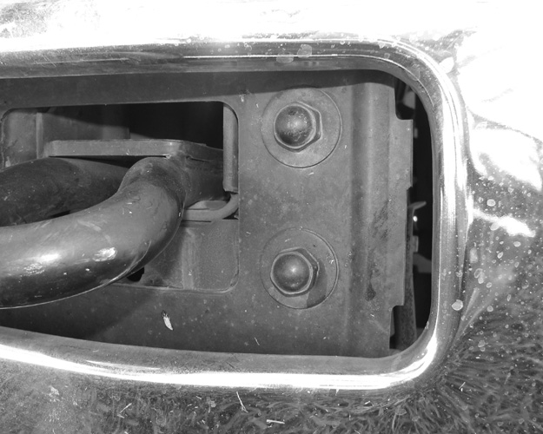
(Fig 4) Remove factory bumper bolts

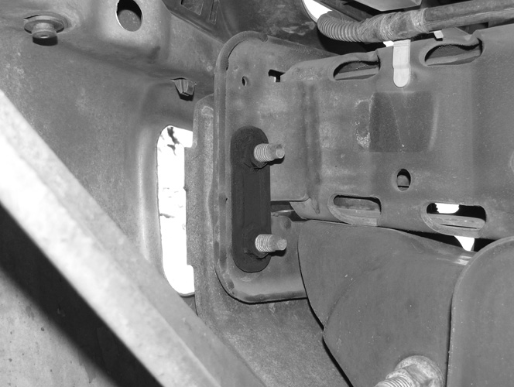
(Fig 5) Double nut plate behind bumper
Front

Driver/left Side Installation Pictured
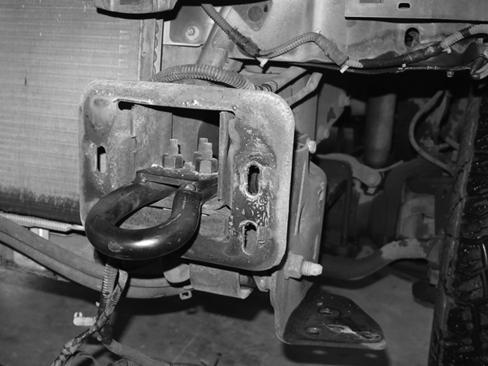

(Fig 6) Remove factory tow hook
Front

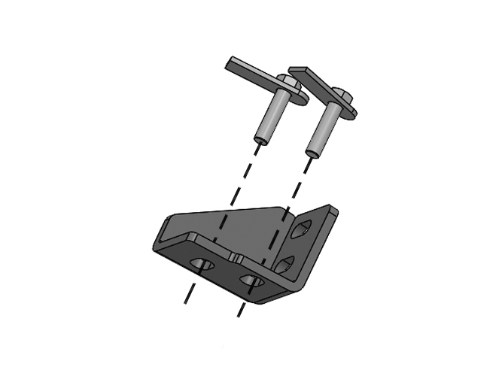
(Fig 7) Insert (2) Single Bolt Plates into the bottom of the Driver/left side Support Bracket
Front
(2) 12mm Single Bolt Plates

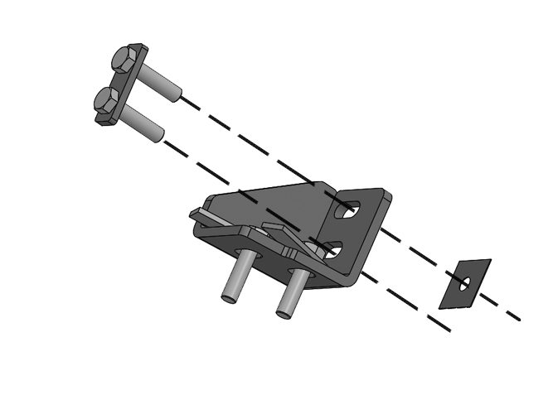
Front
Plastic Retainer
12mm Double Bolt Plate

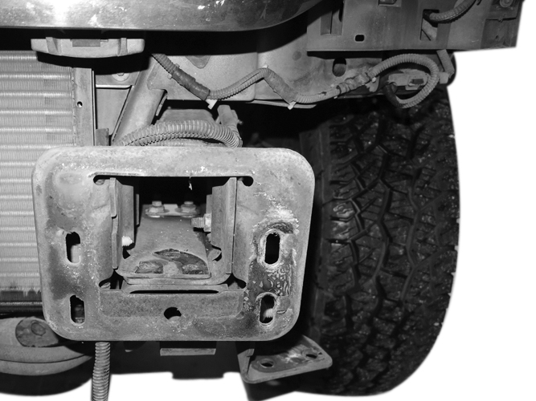
(Fig 9) Driver/left side frame mounting location
(Fig 8) Driver/left side Support Bracket with (1) Double Bolt Plate and Plastic Retainer

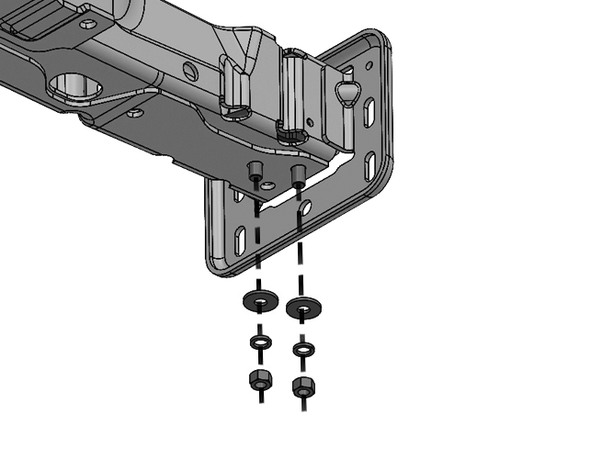
Front
(2) 12mm x 32mm Flat Washers
(2) 12mm Lock Washers
(2) 12mm Hex Nuts

(Fig 10) Slide the Driver/left side Support Bracket assembly into the channel on the frame. Insert the Single Bolt Plates in through the bottom tow hook holes on the frame.

Driver/left Side Installation Pictured
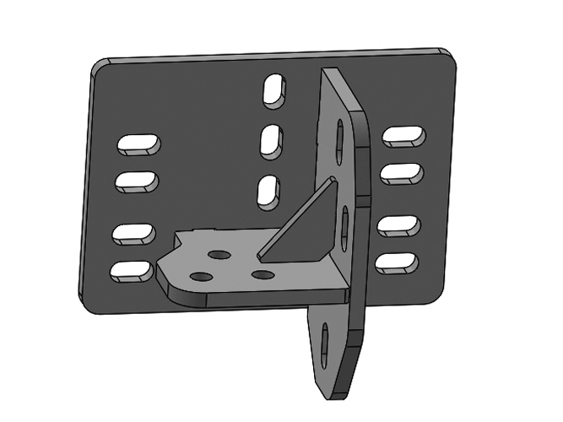

(Fig 11) On 99-04 models, use the mounting slots in the illustration above, (arrows)

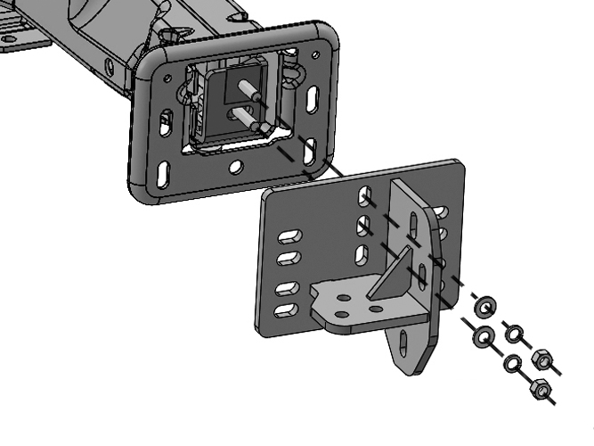
(Fig 12) On 05-07 models, use the mounting slots in the illustration above, (arrows)
(Fig 13) Driver/left side Frame Bracket attached to the Support Bracket
Front
(2) 12mm x 24mm Flat Washers
(2) 12mm Lock Washers
(2) 12mm Hex Nuts

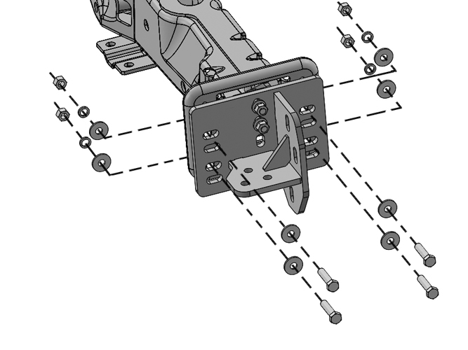
(Fig 14) Driver/left side Frame Bracket attached to the frame
Front
(4) 12mm x 50mm Hex Bolts
(8) 12mm x 32mm Flat Washers
(4) 12mm Lock Washers
(4) 12mm Hex Nuts

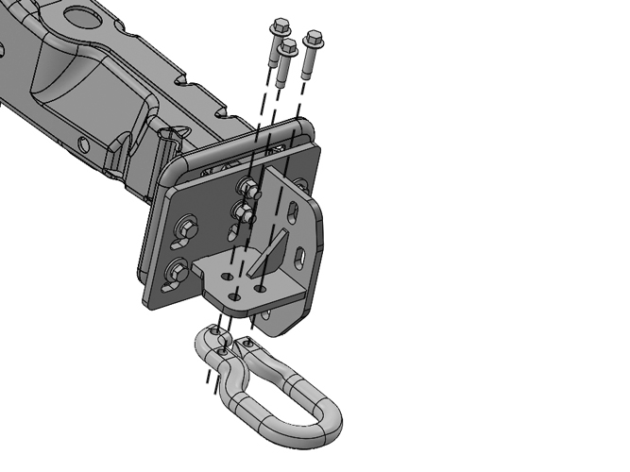
(Fig 15) Driver/left side tow hook attached to the bottom plate on the Frame Bracket
Front
Factory tow hook hardware

Factory tow hook

Driver/left Side Installation Pictured
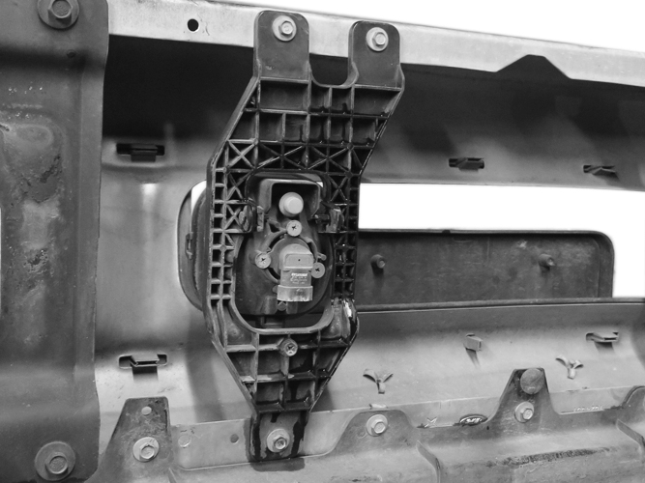
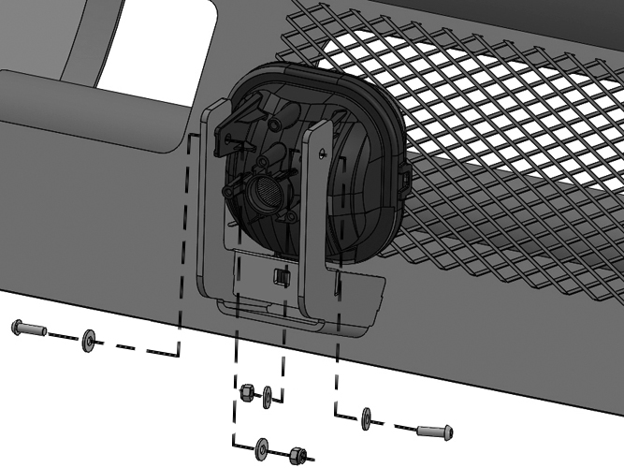
(Fig 17) Driver/left side Fog light attached to the mount on the back of the Bumper
(2) 5mm Hex Bolts
(4) 5mm Flat Washers
(2) 5mm Nylon Lock Nuts

Front

(Fig 16) Remove the fog light from the back of the OE bumper (Driver side Pictured)

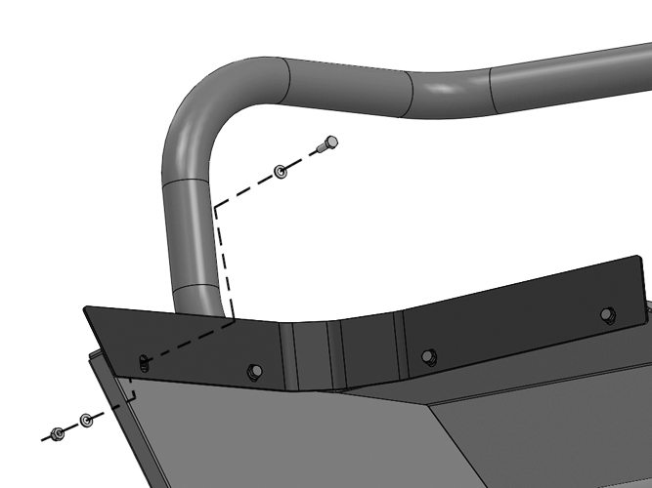
(Fig 18) Driver/left side Fill Panel attached to the Bumper (ONLY 05-07 models)
Front

(4) 6mm Hex Bolts
(8) 6mm Flat Washers
(4) 6mm Nylon Lock Nuts

WARNING! Do not crawl under bumper unless the bumper is properly supported on blocks or stands or the bumper may fall.

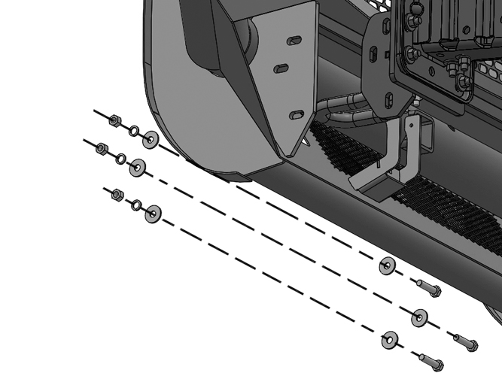
Front
(Fig 19) Bumper attached to the outside of the Driver/left side Frame Bracket illustrated
(3) 12mm x 50mm Hex Bolts
(6) 12mm x 32mm Flat Washers
(3) 12mm Lock Washers
(3) 12mm Hex Nuts

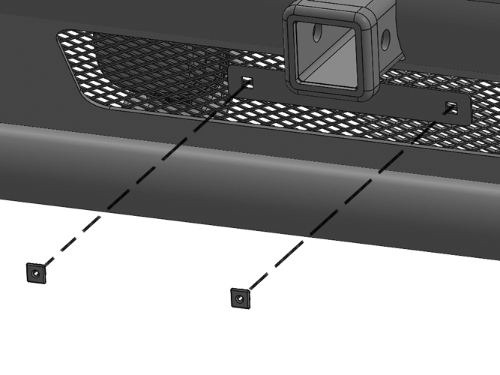
Front
(Fig 20) Attach License Plate to front of Bumper

(2) Plastic Plugs

