PARTS LIST:
1 | HD Replacement Front Bumper Assembly | 8 | 12-1.75mm x 50mm Hex Bolts
2 | Frame Mounting Bracket | 24 | 12mm x 37mm x 3mm Large Flat Washers
2 | License Plate Mounting Plugs | 12 | 12mm Nylon Lock Nuts
4 | 12-1.75mm x 90mm Hex Bolts
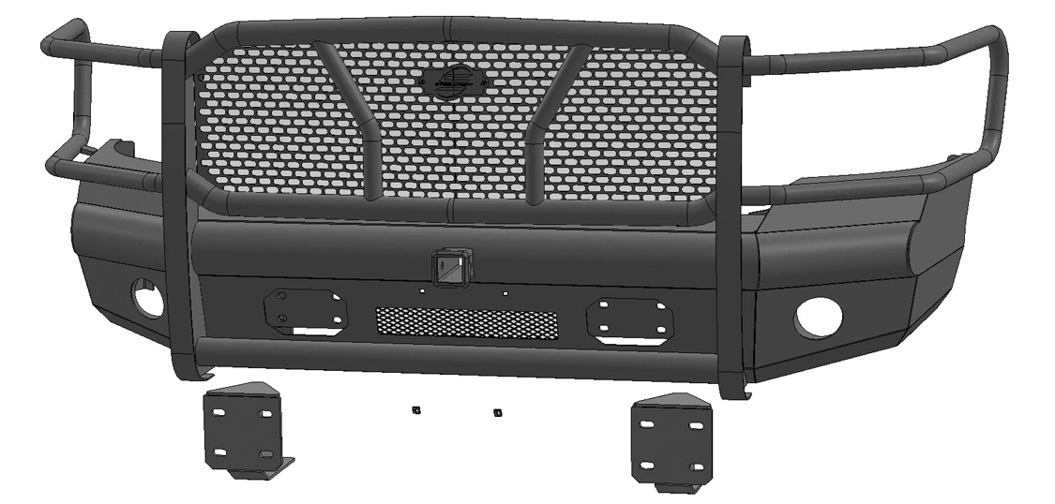

(2) Frame Brackets (left or right)

(2) License Plate Plugs

PROCEDURE:
- REMOVE CONTENTS FROM BOX. VERIFY ALL PARTS ARE PRESENT. READ INSTRUCTIONS CAREFULLY BEFORE STARTING INSTALLATION. BUMPER IS HEAVY, ASSISTANCE IS HIGHLY RECOMMENDED.
- Start installation from under the passenger/right front of the vehicle. Unplug the wiring harness leading to the back of the bumper. Move the wiring harness out of the way.
- With assistance, remove the hex nuts attaching both side of the bumper to the inner bumper brackets, (Figure 1). Once all hardware is removed, slide the bumper off the vehicle and over the tow hooks if equipped.
- Remove the tow hooks from the factory bumper brackets, (Figure 2).
- Next, remove the bumper brackets from the end of the frame, (Figure 4). IMPORTANT: On diesel equipped models, the intercooler must be loosened to remove the double bolt plates attaching the bumper bracket to the inside of the frame, (Figure 3). Remove hex bolts from top of intercooler and with assistance, carefully push intercooler upward to remove double bolt plates.
- Select (1) Frame Mounting Bracket, (Figure 5). Line up (2) slots in the Bracket with the forward mounting holes in the frame for the factory bumper bracket. NOTE: Mounting Bracket is equipped with extra slots to allow fitment on multiple model years. Installation will only use the forward holes in the Bracket, (Figures 5 & 6). Attach the Mounting Bracket to the outside of the frame with (2) 12mm x 90mm Hex Bolts, (4) 12mm Flat Washers, (2) 12mm Nylon Lock Nuts, (Figures 5—7). IMPORTANT: On diesel equipped models, the (2) Hex Bolts with (2) 12mm Flat Washers must be inserted through the frame from the intercooler side first to prevent damage to the intercooler, (Figure 7). Lift intercooler up to insert Hex Bolts (refer to Step 5, Figures 3 & 7).
- Repeat Step 6 to install the driver/left Frame Mounting Bracket.
- Reattach intercooler if equipped.
- Models with factory fog lights:
  - Carefully remove the passenger/right light assembly from the back of the bumper.
  - Reuse the factory hardware to attach the light assembly to the tabs on the back of the Bumper, (Figure 8). Do not overtighten hardware or damage to the light assembly may result.
  - Repeat to install the driver/left fog light assembly.
  - Remove wiring harness from factory bumper. Attach the wiring harness to the back of the HD Bumper and fog lights.
- With assistance, carefully position the Bumper Assembly up to the Brackets, (Figure 9). Temporarily support the weight of the Bumper. WARNING: To avoid possible injury or damage to the vehicle, do not proceed until the bumper is fully and safely supported.
- Line up the (4) holes in the passenger/right side mounting plate on the back of the Bumper with the (4) slots in the Frame Bracket. Attach the Bumper to the Bracket with the included (4) 12mm x 50mm Hex Bolts, (8) 12mm Flat Washers and (4) 12mm Nylon Lock Nuts, (Figure 9). Do not fully tighten hardware at this time. Repeat to attach the driver/left side of the Bumper to the Bracket.
- Level and adjust the bumper to the vehicle and fully tighten all 12mm hardware to 65-70ft-lbs.
- Reuse the factory hardware to attach the (2) tow hooks to the tow hook mounts through the openings in the Bumper, (Figure 10).
- Use the included (2) push-in Plastic Nuts to attach the front license plate, (if required), to the (2) holes in the front bumper, (Figure 11).
- Reattach the wiring harness for the fog lights if equipped.
- Do periodic inspections to the installation to make sure that all hardware is secure and tight.

To protect your investment, do not use any type of polish or wax that may contain abrasives that could damage the finish. Mild soap may be used to clean the Bumper Assembly

Driver Side Installation Pictured
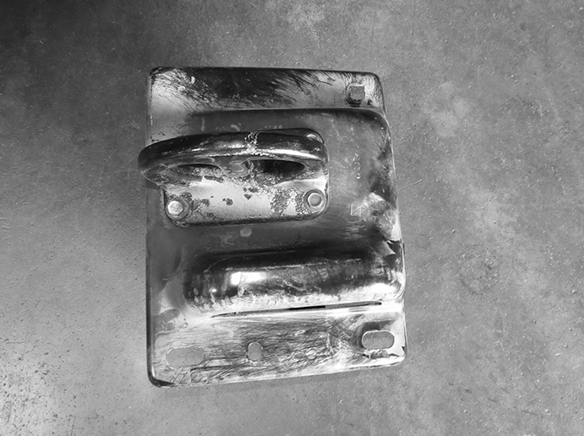
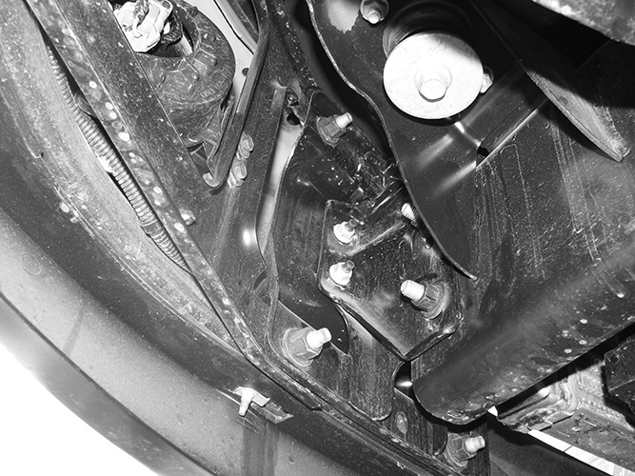

Front

(Fig 1) Remove hex nuts (arrows) to remove bumper from bumper brackets
(Fig 2) Remove tow hooks from bumper brackets then remove brackets from frame

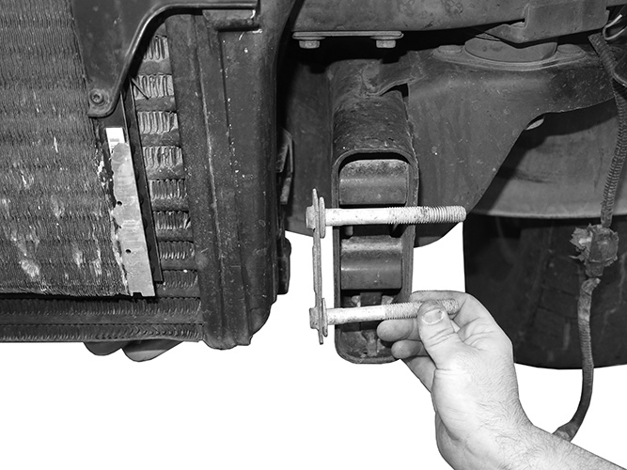

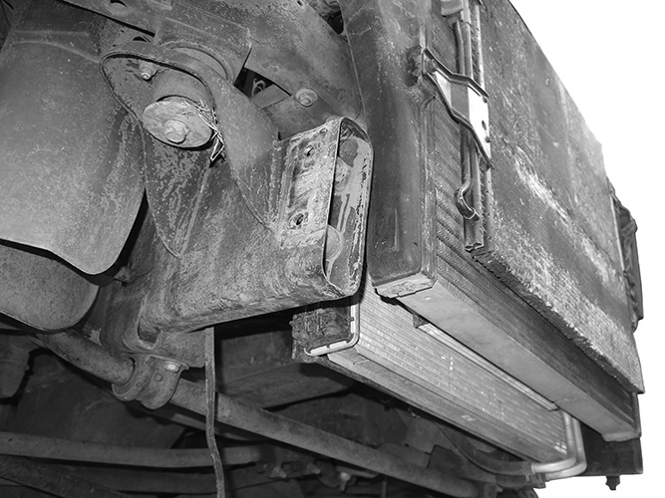
(Fig 4) Passenger/right side of frame pictured without bumper bracket
Front

(Fig 3) On diesel models only: Loosen and lift intercooler up to remove double bolt plates

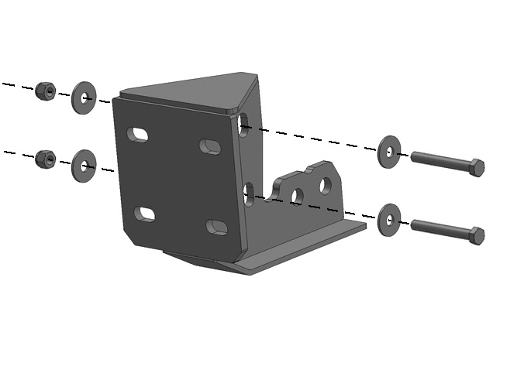

(2) 12mm X 90mm Hex Bolts
(4) 12mm Flat Washers
(2) 12mm Nylon Lock Nuts

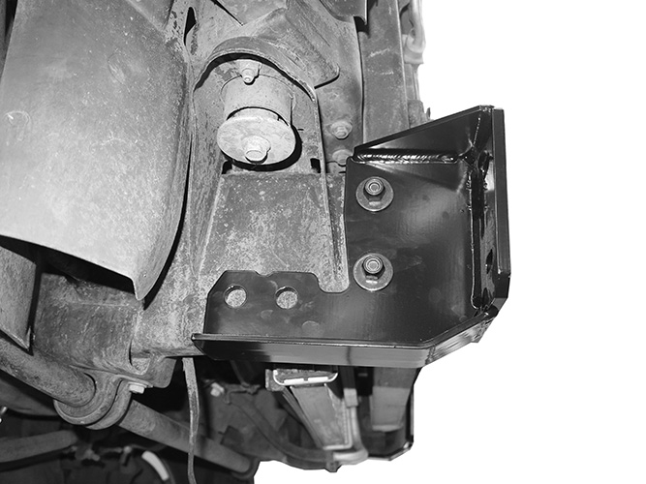
Front
Front

(Fig 5) Attach passenger/right side Frame Bracket to outside of frame

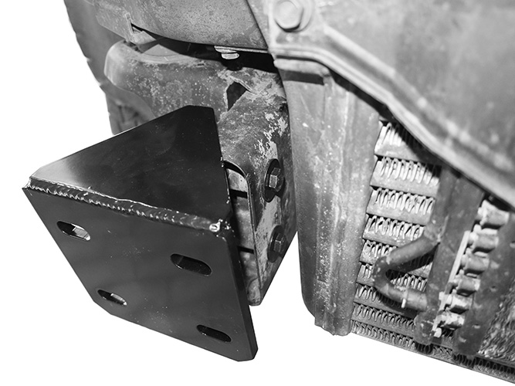

Front

(Fig 6) Mounting holes not used for this particular installation (arrow). Passenger/right Frame Bracket pictured

(Fig 7) On diesel models only: Insert Hex Bolts through frame first, then through Bracket

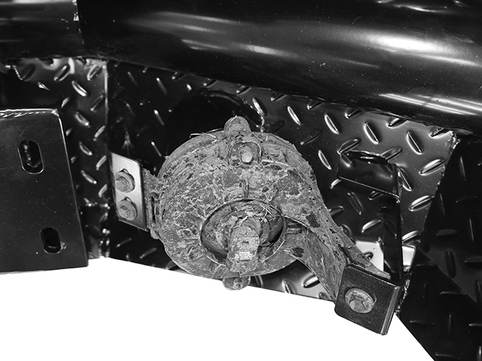

(4) 12mm x 50mm Hex Bolts
(8) 12mm Flat Washers
(4) 12mm Nylon Lock Nuts

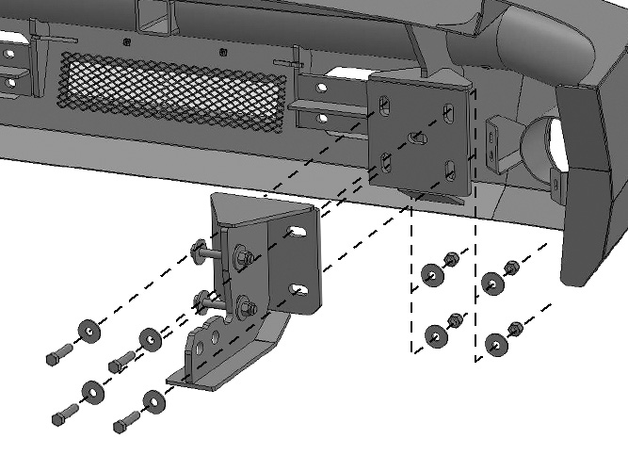

Front

Front
(Fig 8) Reuse factory hardware to attach the fog light to the mounting tabs on the Bumper

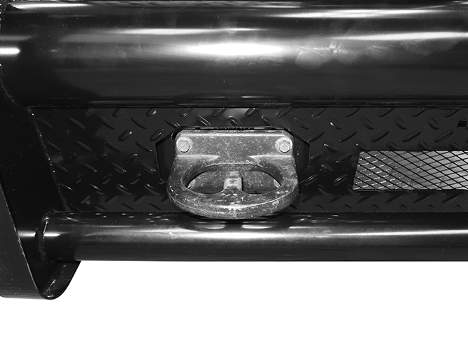

(Fig 9) Attach passenger/right side of Bumper to Frame Bracket

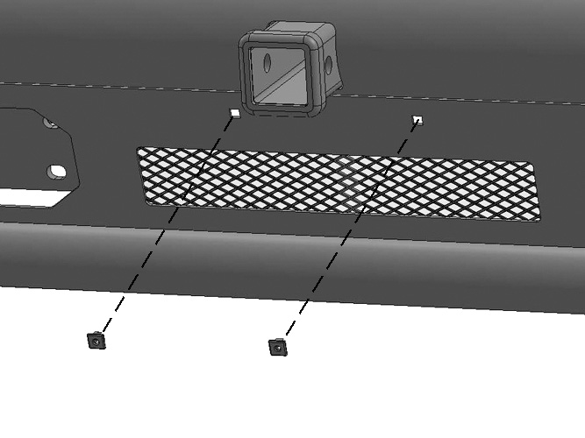

Front

(Fig 10) Reuse factory hardware to attach the tow hook to the mounting location in the Bumper Support Bracket to Frame Bracket and Bolt Plate in cross member

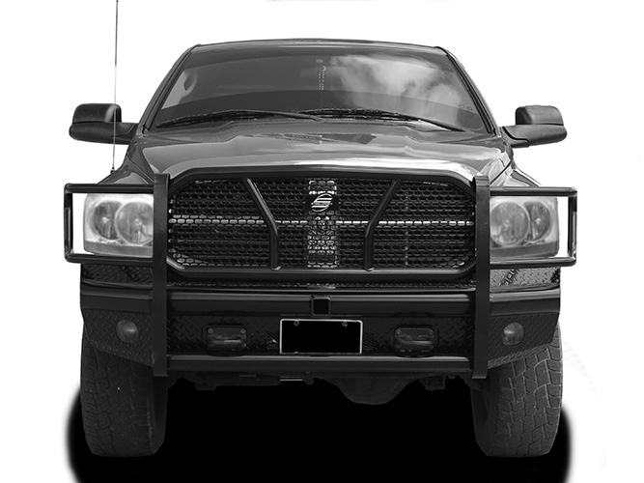

(2) Nylon Plugs

(Fig 11) Push Plastic Plugs into holes in Bumper to attach license plate

Complete Installation

